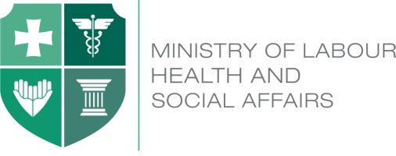

Policy Seminar on Ongoing Reforms of the UHC Program

March 7, 2017

Tbilisi, Georgia

Venue – Training Center, 12 km, David Aghmashenebeli Alley

Agenda (draft)

11:30 – 12:00 Registration and media point

12:00 – 12:10 Address from the Minister of Labour, Health and Social Affairs, David Sergeenko

12:10 – 12:20 Presentation on relevant country experiences

Speaker: Enis Baris, Practice Manager, Health, Nutrition and
Population for the Europe and Central Asia Region, the
World Bank

12:20 – 12:40 International comparisons of the UHC programs

Speaker: Aparnaa Somanathan, Senior Economist and Task Team Leader, the World Bank

12:40 – 13:15 Discussion

